Java instanceof->

*The **java instanceof operator** is used to test whether the object is an instance of the specified type (class or subclass or interface).

**\*The instanceof in java is also known as type *comparison operator* because it compares the instance with type.**

**\*It returns either true or false. If we apply the instanceof operator with any variable that has null value, it returns false.**

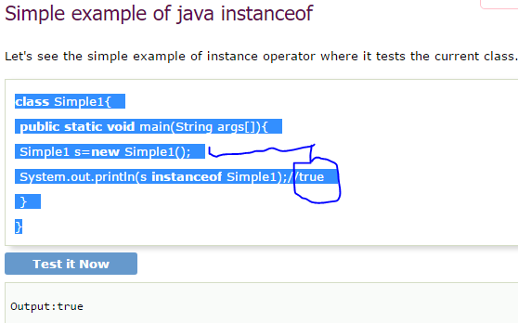

Another example of java instanceof operator->

**An object of subclass type is also a type of parent class. For example, if Dog extends Animal then object of Dog can be referred by either Dog or Animal class.**

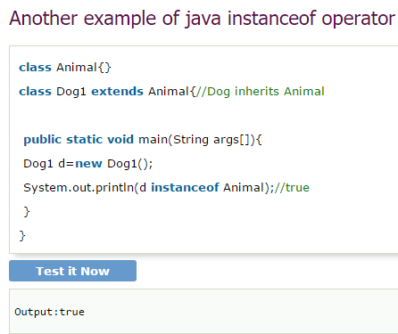

## instanceof in java with a variable that have null value

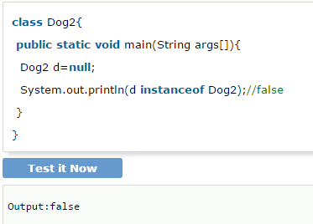

**//downcasting left;**